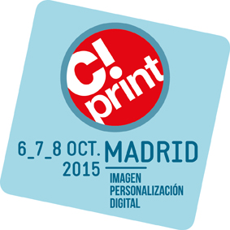
C!Print Madrid: A quality program of workshops and conferences

Press Release
September 2015

Accompanied by a community of experts and high-quality partners, the 2015 edition of C!Print announces a program rich in content on the 6th, 7th and 8th of October in Casa de Campo-Pabellón de Cristal. In this trade show, the visitor can take advantage of the chance to experiment and analyse the latest market trends.

SEE
The guided visits will accompany the visitors throughout the event.
The partners of C!Print, experts in their domains, will be the intermediaries between: announcers, buyers, communities, designers, prescribers, suppliers and transformers.
3 different thematic tours are offered: Print, Decoration and Communication

ANALYSE
The round tables in the conference zone
In the heart of Plug&Play, on the ground floor, this zone will present conferences given by market experts through debates and discussions. As a complement to the applications found in the creative workshop, these conferences will analyse market trends. The common factor: innovation.
- The revolution of the printing market
- Digital printing and decoration projects
- The point of sale of tomorrow
- The future of graphic communication and personalisation
- Graphic design for packaging
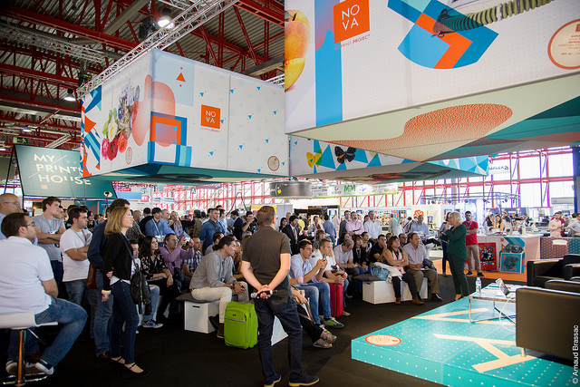
- …

EXPERIMENT
In the C!Print Academy, you will find practical, creative and technical workshops every day:
- Colour Management
- New solutions in sublimation for decoration
- The integration of sublimation as a solution for print-on-demand
- How to design print for interior decoration
- Direct-to-garment printing
- New applications for UV Print&Cut technology
- Wrapping for automobiles and motorcycles
- …
You will also discover creative and technical workshops dedicated to images in all of their forms in the Image Lab area. This space will also present master classes.
Every morning from 10 a.m. to 1 p.m., the Image Lab partners will present a program of master classes. Every collaborator will guide the visitor through the workflow of images by bringing their expertise in areas such as the integration of a visual catalogue, image processing, colour management, 3D visualisation, and creativity and mobility.
Every afternoon, from 1 p.m. to 5:30 p.m., this zone will offer a workshop program dedicated to technical themes particular to image management. This will allow the visitor the opportunity to find the answers directly related to their activities.
Come join the Image Lab partners EVERYDAY at 4 p.m. for the chance to participate in a contest and live the solutions. The more the audience applauds your work, the closer you are to winning a prize!
.ADOBE, FOTOLIA , ITGT, WACOM and LASER PROJECT are already partners of the Image Lab!

Don’t miss out!
Consult our entire workshop and conference program on http://salon-cprint.es/workshops-y-conferencias/
Press Contact
Beatriz Arroyo, Marketing Assistant
marketing@salon-cprint.es / +34 911 983 451

