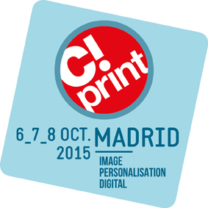
YOUR NEXT PROFESSIONAL EVENT TAKES A WHOLE NEW DIMENSION

Press release
September 2015

Discover the different areas of C!Print Madrid and give a whole new dimension to your profession!
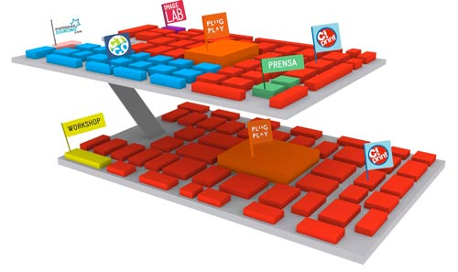
200 exhibitors, 15 000 m2, manufacturers, providers, transformers, service providers, prescribers, designers, announcers and clients. All the actors of the sector will be there: 3 days with workshops, round tables, guided visits, study cases and live demonstrations.

GROUND FLOOR:
- PLUG&PLAY: Wide format printing machines and medias. On-stage application with different areas: a pop up store, a bar, a meeting room and a conference room.
- WORKSHOPS: 3 days of learning and training. Four appointments a day with practical, creative or technical workshops.

UPPER FLOOR:
- IMAGE LAB: Master classes dedicated to the study of all types of images. Every day, experts such as ADOBE, FOTOLIA, ITGT and WACOM will give master classes about this subject.
- PLUG&PLAY: Applications and garment and gift personalisation. You will also be able to see the applications piloted with the web-to-print solution, in collaboration with the integrator Gateway 3D.
- CTCO: Promotional garment and gift: 30 exhibitors, 2 000m2 The leaders of the promotional garment and gift sector An area connected with small personalisation solutions to diversify your communication offer and give another dimension to your profession!
- EUROPEAN SOURCING: Discover the free search engine of promotional products, and attend live demonstrations of a website creation.

Visit C!Print and order your free badge online on: http://www.656events.com
Press contact:
Beatriz Arroyo, Marketing assistant
marketing@salon-cprint.es / +34 911 983 451

