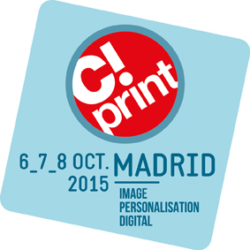
Press release
September 2015
5 reasons to visit
C! Print Madrid

From the 6th to the 8th of October 2015, C!Print will be the place where it all happens! At Casa de Campo - Pabellón de Cristal, this trade show will present new business outcomes and opportunities to the visual communication and personalisation sectors.

Here are 5 reasons you cannot miss C!Print 2015!

1. C!Print Madrid is your chance to experience a professional trade show dedicated to the visual communication and personalisation industries. It focuses not only on innovative applications for the visual communication market but also for interior decoration, architecture, events and promotional garments and gifts.

2. C!Print is supported by industry professionals!
You will find more than 200 exhibitors, brands, and machines and consumables suppliers, including the leaders of the market: CANON, EPSON, EXAPRINT, HEXIS, HP, MIMAKI, MUTOH, ROLAND, SIGN TRONIS S.A. etc.…

In addition, the press as well as professional organisations recognize C!Print as an important industry event and partner with the trade show!

AP DIGITALES / ALABRENT / EPPI / EL PUBLICISTA / IMPREMPRÉS / INDUSTRIA GRAFICA ONLINE / INTEREMPRESAS / LA PRENSA / LARGE FORMAT REVIEW / PRESSGRAPH / PROSIGN / REPROPRES / VISUAL / VISCOM UP / WORLD PRESS ONLINE.

FESPA ASOCIACIÓN / ASERLUZ / ASOCIACIÓN EMPRESARIAL DEL COMERCIO TEXTIL Y COMPLEMENTOS / ASSOCIACIÓ EMPRESARIAL DE PUBLICITAT / ASOCIACIÓN GENERAL DE EMPRESAS DE PUBLICIDAD/ ASOCIACIÓN ESPAÑOLA DE AGENCIAS DE COMUNICACIÓN PUBLICITARIA / ASOCIACIÓN ESPAÑOLA DE REPROGRAFÍA / BARCELONA CENTRO DE DISEÑO / CONSEJO GENERAL DE COLEGIOS DE DECORADORES/DISEÑADORES DE INTERIOR DE ESPAÑA / COLEGIO HOGAR / COL.LEGI OFICIAL DISSENY GRÀFIC CATALYNUA / FEDERACIÓN ESPAÑOLA DE PROFESIONALES DE LA FOTOGRAFÍA Y LA IMAGEN / INSTITUTO TECNOLÓGICO & GRÁFICO TAJAMAR / LA CIUDAD DE MADRID / NEOBIS.

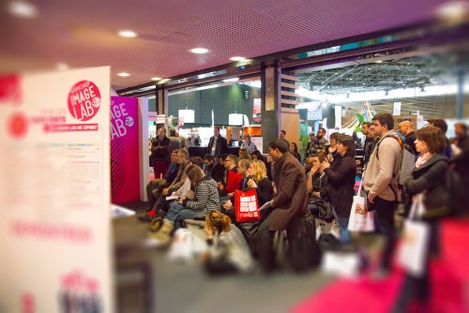
3.Content is at the heart of C!Print’s strategy:
- 30 workshops and case studies
- 30 experts who accompany the visitors throughout the trade show
- 15 conferences and round tables
- 3 specialised themes

4. All of the techniques will be represented:
- Transfer
- Tampoprinting
- Engraving
- 3D printing

- Small and wide format printing on textile
- Sublimation
- Digital printing
- Screen printing
- Embroidery

5.C!Print Madrid puts an emphasis on innovation and creativity. Discover the Plug&Play Creative Workshop, 1000 square meters of animation at the centre of the event, and find the applications that will inspire your next project. From the personalisation of products and textiles to wide format personalisation, this space is the result of a collaboration with digital printing designers and professionals.
In this zone you will find:
- A variety of content through conferences
- Inspiration from the personalisation techniques you will see live in the PopUp Store, Plug&Play.
- A space for meetings with industry professionals in a friendly and casual atmosphere at the Business Bar.
Visit C!Print Madrid from the 6th to the 8th of October 2015 by ordering your free badge on http://656events.com with the invitation code CP5RAZONES.

Find more information go to http://salon-cprint.es/en.
Press contact:
Beatriz Arroyo,
marketing@salon-cprint.es / +34 911 983 451

