Press release
Screen-printing, at the heart of C!Print Madrid, with Charlie’s Corner

August 2015

Screen printing will be proudly presented at C!Print Madrid on October 6th, 7th and 8th 2015 at Casa de Campo - Pabellón de Cristal, by Charlie Taulieb, a true screen printing on textile expert. He will animate the « Charlie’s Corner’s » workshop during the 3 days of the trade show with live demonstrations in textile screen-printing.

Come meet Charlie at the Plug&Play area and discover all his tips and tricks, such as: personalising a t-shirt with special effects, printing on dark fabric, etc.

For this event, INKEMI will provide CARUSSEL M&R carousel as well as the TINTAS RUTLAND inks. Charlie will use GILDAN t-shirts for his demonstrations.

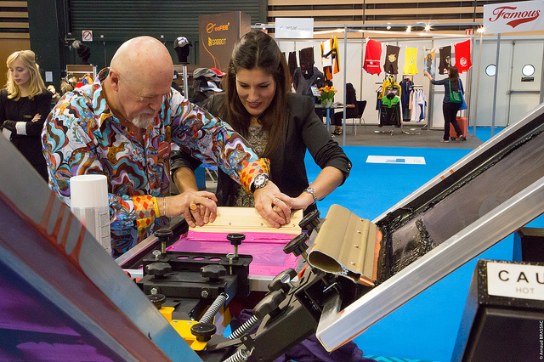

Other exhibitors will present their screen printing material at the trade show (carousel and inks): AFFORD INKS, COLOR-DEC ESPANA, EXPARINT IBERIA, HISARNOX, INNOPRINTER, J.PUJOL, MARKAMANIA, ROTULATIENDA, ROTUTECH, STX RADIAL AMBIENT S.L., SERIGRAFIA VINILO, TECNOPRINT DIGITAL, TRANSFERTPRESS, TU DIRAS S.L…
*List from 08/26/2015

Consult the complete exhibitor list on: http://salon-cprint.es/en/exhibitors-list/
Press contact:
Beatriz Arroyo,
marketing@salon-cprint.es / +34 911 983 451

